St Luke’s Uniting Church – House Church
Sunday 21st June 2020

“Black Lives Matter … All Lives Matter … A Discussion on Racism from a Christian Perspective”

Background Papers

Baruch professor reflects on George Floyd and others instances of police brutality in Essay

The Ticker (https://theticker.org/ticker/2020/6/12/baruch-professor-reflects-on-george-floyd-and-others-instances-of-police-brutality-in-essay)

Professor Regina Bernard sat at her computer typing an essay about how the COVID-19 pandemic affected her.
While doing her final edits, she saw in her peripheral vision a news story out of Minneapolis about a man she did not know.
A story that has taken over entire streets, entire blocks, entire cities. For 8 minutes and 46 seconds, onlookers watched as George Floyd died with a police officer’s knee on his neck while being arrested. His last words were “I can’t breathe.”
Bernard looked on in shock, tears running down her face and onto her keyboard. What she was currently writing no longer mattered. Instead, it needed to be about those 8 minutes and 46 seconds.
“I think it happened almost immediately,” said Bernard, a professor from the Black and Latino Studies Department who teaches about race, class, urban education and engaged activism.
She wrote her essay, “Why We Can’t Breathe,” for George Floyd. Floyd’s death has shaken an entire nation with a pain that is all too painfully familiar. Bernard herself is still recovering from the deaths of Sean Bell, Anthony Baez, Breonna Taylor and Freddie Gray, all at the hands of police officers.
“Your breathing, my breathing, the rising and falling of lungs in black and brown bodies should not come at the discretion of anyone else. It is not a privilege to breathe,” her essay reads in part.
This excerpt summarizes what happened to Floyd at the hands of police and what has happened to all of those before him.
Her story comes from a personal place, experiencing throughout her lifetime the impact that these deaths have had. Each of these deaths were a new chapter in a book of discrimination. From Floyd, she was reminded of Baez and from him many others spanning decades of discrimination.
“It’s becoming murky,” she wrote. “The names, the incidents, the actual meaning of our liberties and our injustices and our existences, all muddled . . . I think that my heart is broken, still very much broken, for George Floyd, his family and all of the ones that have come before him.” Bernard is a scholar on the subject of race, writing educational books as well as essays covering topics for people of color. Some of her essays are featured in the Journal of Pan African Studies.
Toward the end of her essay, Bernard mentions the troubling fact that she only knew these people’s lives in their final hours.
“Eric Garner, I shed a tear as I watched you die,” she wrote. “I know nothing about you, or about the lives of any people I mentioned, yet I know about the final hours. I saw it.”
Bernard connects to many events that have led to this pain and now blurry history. “I really firmly believe that if we do not recognize our history and admit that we have been involved in some kind of breakdown, in some kind of origin of hate, we can never move forward,” she said.
To her, if progress is to be made, there needs to be a reflection of the institutions that protect us and society as a whole. Right now, the community does not have faith in those institutions and have taken to the streets to create change.
Bernard believes that this is what the protests are about.
“Coming together sort of looking at our humanity working collectively at the table with those who deem themselves authority or those who call themselves in charge,” she said.
“If there are people debating how these protests should run, I think we are missing the point of what it was that the entire nation saw last week,” she said in response to those who believe these protests are invalid. “There shouldn’t be. There really shouldn’t be. I mean we watched a man executed on television; I mean just point blank.”
Much like the deaths before Floyd, change was expected but did not come.“For me, and a lot of us it is a wait and see,” she explained. “Because I know I also watched Eric Garner be put in a choke hold on national television and we thought it was global outrage and the verdict comes out and it’s not.”
Bernard said she is afraid of being too hopeful at this early stage and is waiting like everyone else.
“None of this will bring back any of the dead, but how can we protect the ones in the future I think is the big question,” Bernard said.
Her essay’s final sentence carries a powerful message, shared by many: “Mr. George Floyd, I cried for you last night. I cried for the ones who died before you. I cry for the ones to come. All the crying makes it hard to breathe.”

Please also read:

- “Why We Can’t Breathe” - click on link in the body of this paper, and
- The Statement on how 433 plans to continue supporting the current protests -- there is a link at the top of the “Why We Can’t Breathe” article.
- ‘I can’t breathe!’ Australia must look in the mirror to see our own deaths in custody” (https://theconversation.com/i-cant-breathe-australia-must-look-in-the-mirror-to-see-our-own-deaths-in-custody-139848) -- reprinted on next page

‘I can’t breathe!’ Australia must look in the mirror to see our own deaths in custody

I can’t breathe, please! Let me up, please! I can’t breathe! I can’t breathe!
These words are not the words of George Floyd or Eric Garner. They weren’t uttered on the streets of Minneapolis or New York.
These are the final words of a 26-year-old Dunghutti man who died in a prison in south-eastern Sydney.

Read more: The fury in US cities is rooted in a long history of racist policing, violence and inequality

David Dungay Jr was killed when prison officers restrained him, including with handcuffs, and pushed him face down on his bed and on the floor. One officer pushed a knee into his back. All along, Dungay was screaming that he could not breathe and could be heard gasping for air.
Dungay’s death in custody occurred in Long Bay prison during the 2015 Christmas season. It happened a short drive from an elite university, next to affluent, waterside suburbs.
But his horrific death did little to pierce this white bubble of privilege. The media barely blinked. The politicians did not emerge from their holiday retreats. None of the officers involved were disciplined or called to account.

Australia’s glass house
It is comfortable for us in Australia to throw stones at racist police violence in the United States. It is comfortable because we do not see our own glass house.
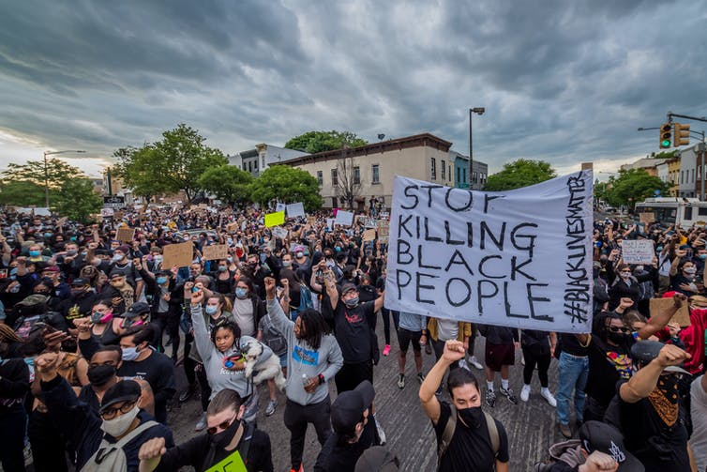Protests have broken out in the United States over the death of George Floyd. Erik McGregor/AAP
This is evident in Prime Minister Scott Morrison’s comments to 2GB on Monday:
And so as upsetting and terrible is the murder that took place, and it is shocking … I just think to myself how wonderful a country is Australia.
It is “wonderful” because we do not see the horror inflicted by the criminal justice system on First Nations people.
It is “wonderful” because we do not ever call their deaths in custody “murder”, using instead the euphemisms of “accident” or “natural causes”.
It is “wonderful”, because we have so normalised the passing of First Nations people that we are never shocked when they are killed.
It is “wonderful”, because we have a vocabulary to defend police officers responsible for racist violence, including people doing an “extremely difficult job”.
The official response to the killing of Dungay has wide ripples in the white Australian community and the legal community. His family maintain that the killing of their son, brother and uncle, who was unarmed, was murder. No criminal charges have been brought and the coroner in November 2019 blamed Dungay’s pre-existing health conditions. His comments minimised the responsibility on the part of the officers:
it is most likely that the cause of David’s death was cardiac arrhythmia. It is noted that David had a number of comorbidities, both acute and chronic, which predisposed him to the risk of cardiac arrhythmia … However, the expert evidence also established that prone restraint, and any consequent hypoxia, was a contributing factor although it is not possible to quantify the extent or significance of its contribution.

First Nations people are the most incarcerated in the world
The deaths in custody of First Nations Australians are not hidden. As a nation, we are choosing not to look at them. In 1991, the Royal Commission into Aboriginal Deaths in Custody documented 99 deaths in custody.
Since then, 432 Indigenous Australians have died in custody, according to Guardian Australia’s Deaths Inside project.
First Nations people are the most incarcerated in the world, surpassing the rates of African American people in the United States. In 2019, for every 100,000 First Nations adults, 2,481 are in prisons, compared with 164 non-Indigenous people.

Read more: FactCheck Q&A: are Indigenous Australians the most incarcerated people on Earth?

Despite comprising 2% of the general adult population, First Nations Australians are 28% of the prison population. For First Nations women, the rate is 33% and they are 21 times more likely to be imprisoned than non-Indigenous women. This is a product of systemic racism that also contributes to disproportionate deaths in custody.
Yet the deaths are only the tip of the iceberg. Everyday occurrences of police brutality against First Nations people, frequently filmed and uploaded on social media platforms, have even less formal oversight. The casual complacency about the harm inflicted on First Nations people means we do not know the true extent of its occurrence.
On Tuesday, a NSW police officer was put on restricted duties after a video emerged on social media of him appearing to kick an Aboriginal teenager.

Protesting deaths in custody in our backyard
In the wake of Floyd’s death, Dungay’s nephew, Paul Silva pointed to the lack of response to First Nations deaths in Australia:
We don’t get the same big response in Australia as they do in the United States with the Black Lives Matter movement, but we have had many people, both First Nations and non-Indigenous people standing with us. We can build on that – we need many more to join us. We can take inspiration from the United States and get back out on the streets in our own backyard, where there is so much brutality against Black people too, that’s the only way to get justice.
While the spotlight has been shone on the protests in the United States, most Australians would be unaware that each year on the anniversary of Dungay’s killing, there has been a protest, mostly at Long Bay jail.
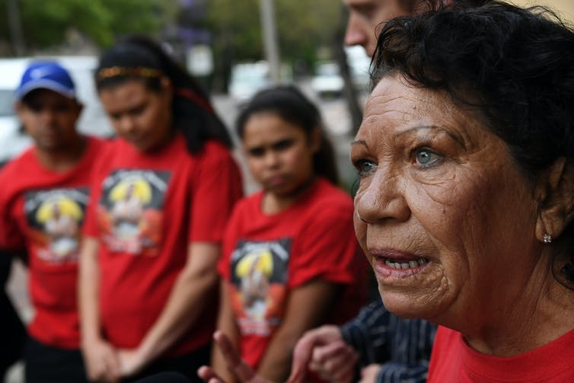Leetona Dungay continues to protest about her son’s death. David Moir/AAP
This week in cities around Australia, protests are planned in the name of First Nations people who have died in custody. The numbers of those who converge on the streets is a litmus test of national tolerance for racial violence against First Nations people in the criminal justice system.

Where does racial violence against First Nations people end?
Despite more than 500 First Nations deaths in custody since 1980, there has never been a successful homicide prosecution in the criminal courts. Indeed, only a handful have resulted in charges being laid in manslaughter or, less frequently, murder.
A police officer has been charged with murder following the shooting death of a 19-year-old Warlpiri man last year. The officer intends to plead not guilty.

Read more: Three years on from Uluru, we must lift the blindfolds of liberalism to make progress

The Victorian Coroner this April also referred the death of Yorta Yorta woman Tanya Day to prosecutors for further investigation.
Without accountability, justice will not flow for the families and the chain of racial violence will not be broken.
The danger of expressing outrage towards African American deaths in custody is that we deflect our own agency and responsibility. We legitimise the violence at our doorstep that is in our control.
It allows us to walk past racist police interventions on the false assumption that the problem is with the First Nations person rather than the police and Australian culture.
The only response to racism is resistance. This must take place not simply in passive solidarity with African Americans, but in our active support, protest and sacrifice for the lives of First Nations Australia.

A Uniting Church Statement About Justice for Indigenous Australians

The Uniting Church hopes for a nation which acknowledges the rights of Indigenous Australians as the first people of this land, respects the land on which we live, and is committed to empowering Indigenous people to take control of their own lives and destinies.
Indigenous communities, both remote and urban, experience heightened levels of disadvantage. Indigenous Australians have worse health, education and employment outcomes across the board than the non-Indigenous population. Justice for Indigenous people will depend on policies which ensure resourcing in areas of health, housing, education, employment and welfare support.
At its 7th Assembly, the Uniting Church formally entered into a relationship of Covenant with its Indigenous members, recognising and repenting for the Church's complicity in the injustices perpetrated on Australia's Indigenous community, and pledging to move forward with a shared future. Congress' generous response to this statement, among other messages, called upon the broader Church to take up the mission of reconciliation.
The ongoing and continually renewing nature of the Covenant calls the Uniting Church to continually act to remove the systems and structures of discrimination and oppression in Australia.

Thursday, 16 August 2018

A Christian response to racism
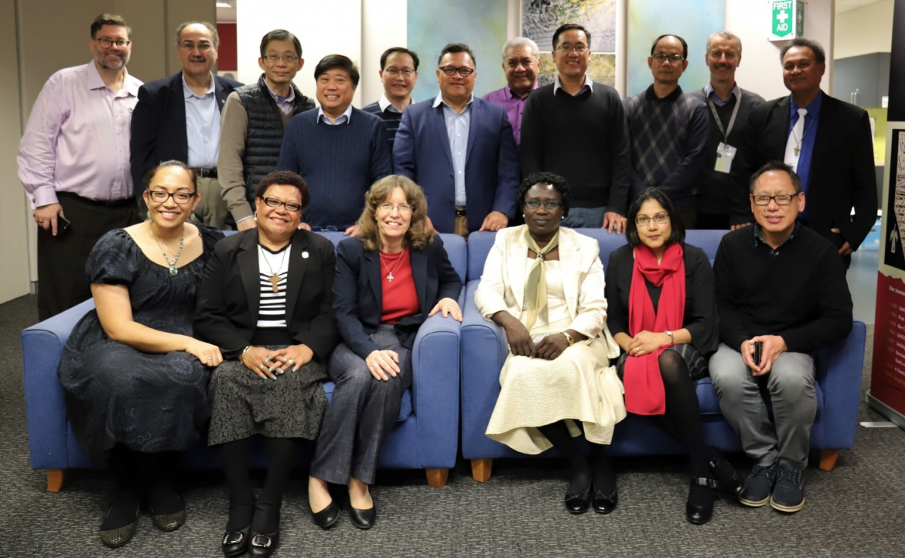
President of the Uniting Church in Australia Dr Deidre Palmer has called on Australians to respond with love, hospitality and inclusion to a surge in anti-immigration rhetoric in Australian public life.
“Jesus’ great commandment to his followers was to love God and love your neighbour. As Christians we believe all people are created in the image of God and deserving of respect and dignity. Racism is incompatible with the Christian faith,” said Dr Palmer.
In recent weeks, inflammatory opinion pieces have suggested a “foreign invasion”, a neo-Nazi has been allowed to air his views on a news channel; there has been more fearmongering about so-called “African gangs”, and a Senator has used his maiden speech to honour the White Australia Policy and call for future migration to “reflect the historic European-Christian composition of Australian society."
“The Uniting Church is a proudly multicultural church. Our ministry in Christ continues to be powerfully transformed by the strong and flourishing intercultural community we hold across our diversity,” said Dr Palmer.
“Every day I thank God for the blessings of our gloriously multicultural Church.
“I was delighted to meet leaders of eleven of the Uniting Church’s National Conferences in Sydney recently and to hear first hand about their amazing ministry, which is transforming lives and communities around them. These Conferences include Uniting Church members from South Sudan, Indonesia, the Philippines, Tonga, Samoa, Fiji, the Middle East, Vietnam, Niue, Korea, and China.
“When I think of ‘Christian values’ I think about overcoming racism and discrimination in all its forms. In his ministry, Jesus challenged religious and social prejudice and sought to break down the barriers that separate us from each other socially, religiously, culturally and politically. Christian values are about inviting people to create communities, where all people can flourish.”
Outgoing Race Discrimination Commissioner Dr Tim Soutphommasane recently condemned politicians for race-baiting and sections of the Australian media industry of using racism as part of their business model.
Dr Palmer called on Church members to boldly bear witness to the reconciling ministry of Christ that we proclaim.
“Jesus’ call is to love in the face of hatred and to embody God’s generous hospitality. As Martin Luther King Jr famously observed - hate cannot drive out hate; only love can do that.”
“So I urge Uniting Church members and all Australians to embrace the multicultural nature of our society and respond with love and compassion to those who are being made to feel unwelcome,” said Dr Palmer.

MESSAGE FROM THE
NATIONAL COUNCIL OF
CHURCHES

A Call for Racial Justice

In a world so full of fear and distrust, it is timely
that Social Justice Sunday 2003 addresses issues of
racism.
Christians believe that all human beings are created
in the image of God. In Jesus Christ the divisions
that separate people from each other are broken
down – people are reconciled and a new unity is
created among us.
Racism separates us from God and from each
other and is incompatible with the Christian gospel.
Together with Christians all over the world, we
affirm that racism is a sin.
It is a sad fact that racism has been a part of
Australia’s history. It is evident in the life of
individuals, communities, and churches and
enshrined in government policies. Responses to
recent events throughout the world indicate that
we have not rid ourselves of the racism which has
defined so much of our history. Racism has always
been a form of violence, damaging the lives of those
who experience it and violating their human rights.
In seeking to understand how racism works
we need to listen to the experiences of others
and reflect on differing perspectives. We need
to consider what is happening to Indigenous
Australians, how authentic our multicultural identity
really is, the assumptions that underlie our resort
to warfare in recent times, and the lack of safety
which people of some religious and ethnic groups
experience everyday. We need to examine what
is happening in sport, the workplace, politics, the
media and in our own congregations and churches.
While racism may at times be subtle and well
disguised, it is always a powerful force of oppression
and injustice. We condemn the continuing racism
in our country which is evident in the behaviour
of individuals and communities and which is still
evident in our churches. We condemn the racism
which is hidden in the systems and structures of
our society.
We believe that the cultural and racial diversity
in Australia today is a reflection of God’s gift of
diversity in creation. It is to be treasured and
nurtured, regarded as a blessing for us all.
We call for racial justice – an acknowledgement in
word and deed that all people are created equal
and that the lives of all people are equally valuable.
We seek a community in which strangers are
welcomed and differences are celebrated; we seek a
society where the systems, structures and policies of
governments and institutions are racially inclusive;
and we seek a country in which all people are
valued and can worship according to their own faith
tradition.
We encourage members of our churches to use
the opportunity provided by Social Justice Sunday
2003 to reflect on our own lives and the lives of our
churches; to seek God’s transformation of our lives
and healing of our communities; and to work for
racial justice so that we may be faithful agents of
God’s transforming mission in our society.
This statement has been endorsed as a public
[[

This statement has been endorsed as a public statement and for inclusion in the Social Justice Sunday Kit (Social Justice Sunday 2003) by the following church of the National Council of Churches in Australia:
Anglican Church of Australia
Antiochian Orthodox Church
Armenian Apostolic Church
Assyrian Church of the East
Churches of Christ
Congregational Federation of Australia
Greek Orthodox Church
Lutheran Church of Australia
Religious Society of Friends
Roman Catholic Church
Romanian Orthodox Church
Salvation Army
Syrian Orthodox Church
Uniting Church in Australia

