Messy Church … Consider the question below … You might like to share your thoughts at the Zoom session on May 1st.

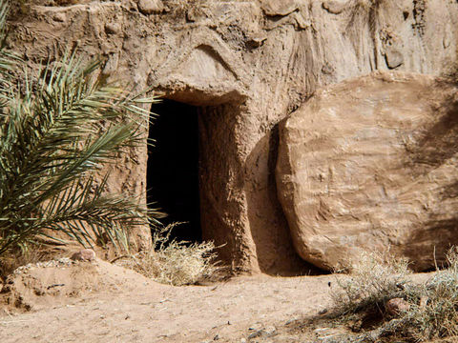
The Resurrection
“… the angel said to the women, “Do not be afraid; I know that you are looking for Jesus who was crucified. He is not here; for he has been raised, as he said. Come, see the place where he lay. Then go quickly and tell his disciples, ‘He has been raised from the dead, and indeed he is going ahead of you to Galilee; there you will see him.’” (Matthew 28: 4-7)
A Question to Consider an
What has Easter meant for you this year???

This could include some “show and tell”:
You could show some craft activities you did, food you enjoyed or even some pictures.

