

St Luke’s Environment

Action Group

Highlights of 2017

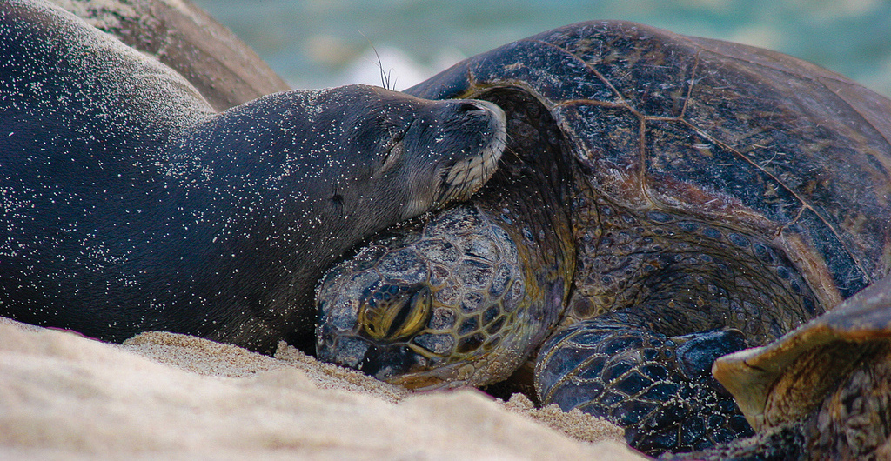



St Luke’s Environment Action Group

2017 Report

ALL YEAR **Vege Patch for the Food Bank at Uniting Barwon**

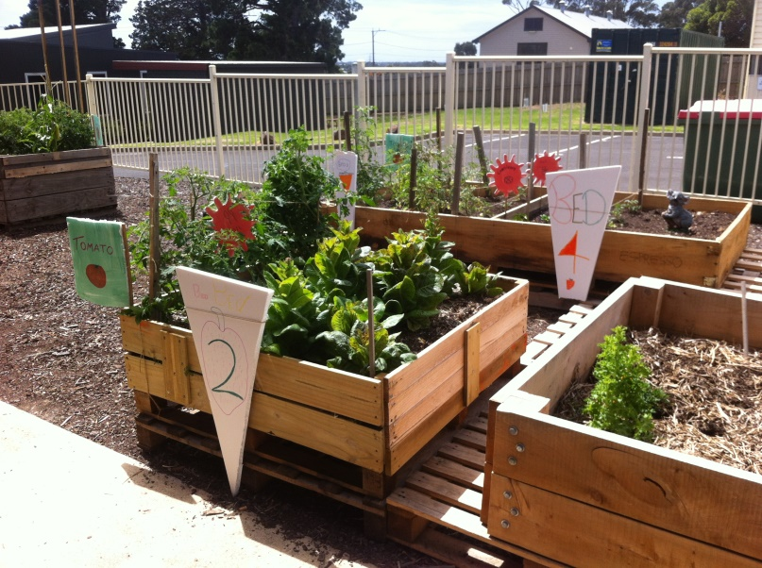

Messy Church participants did a wonderful job on making labels for the Vege Patch for the Food Bank at Uniting. Many thanks to those who took part.

The vege patch has supplied the Food Bank with an abundance of fresh vegetables.

MARCH **Be part of the biggest faith based Community Climate Petition**.

Later this year, the Federal government will review its climate policy. We think this is an important moment to send a strong message that our Christian faith calls us to care about our neighbours and future generations and therefore we want strong action on climate change.

This year the JIM Unit will be working with other synods as well as other faith and development organisations across Australia to have maximum impact! Together we are going to collect thousands of signatures on a petition that calls on the Australian Government to take stronger action to reduce our emissions, transition away from fossil fuels and towards renewable energy, and support our poorest and most vulnerable neighbours as they face the increasing impacts of climate change.

One petition in one electorate might be possible to ignore. Any number of email petitions can be deleted. But one hundred-and-fifty old-school, pen and-paper petitions, gathered by churches, faith communities, schools, businesses and community groups across all of Australia’s 150 electorates is hard to ignore. By coordinating our efforts, handing the petitions to MPs at one key moment, and having our requests heard by Parliament, we will make it impossible to ignore.

This is going to be our major campaign for the year and will involve lots of moments along the way for you to be involved.

The petition will also build a strong sense of public pressure and momentum at a time when the Government is assessing whether our emissions reduction targets are an adequate contribution to global efforts to tackle climate change and whether our climate policies are reducing emissions far and fast enough. (Hint: they’re not, not even close!)

**How to get involved:**

**SIGN the petition in the foyer**

APRIL 22 **Earth Day**

St Luke’s Environment Action Group plus Highton Rotary plus Curlewis, Clifton Springs Coastcare carried out a litter survey at The Dell, Clifton Springs. The findings were then sent to the Port Phillip Eco Centre to be entered onto their data base. These surveys are taken around the bay to determine where the rubbish is coming from and action taken accordingly.

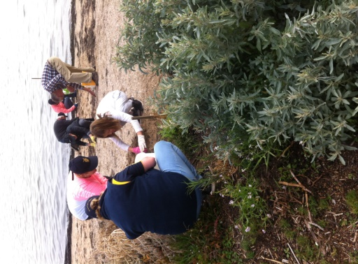 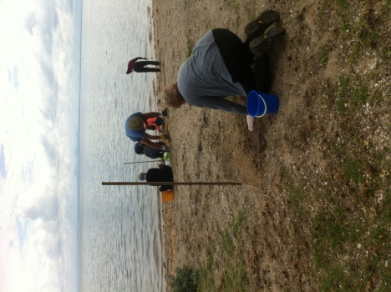 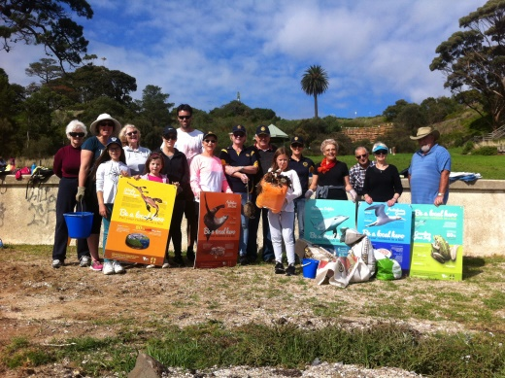

Why is this being done?

We have a number of beautiful creatures living in Port Phillip Bay (over 80% found nowhere else on earth) and our rubbish is affecting them, often fatally. The fish eat the litter, the plastic either kills them or stays in their tissue and then we eat it, affecting ourselves as well.

Statistics show we will have more plastic in the sea than fish by 2050 if we continue as we are. There are many “rafts” of litter floating in the sea one of which washed up on Australian shores – 1 metre in length, weighing 60kg - held together by semi-melted plastic.

The Good News

We found less rubbish this day at The Dell than when we did the last survey, thanks to regular monitoring and rubbish removals.

JUNE 5 **World Environment Day**

*PLEDGE*

United Nations World Environment Day 5th June

*For 1 month, starting 5th June, I pledge:-*

Option I

No Plastic Bags – I will take my own shopping bags to the supermarket

Option 2

Live Plastic Free -Take my own coffee cup when I want a take away coffee

-Take my own water bottle

- Use glass containers

- Buy products in glass, paper or cardboard

Bump onto St Luke’s facebook page and share any difficulties living plastic free. Also count the plastic you have used for the month and put that on facebook – let’s see how many good ideas we can initiate.

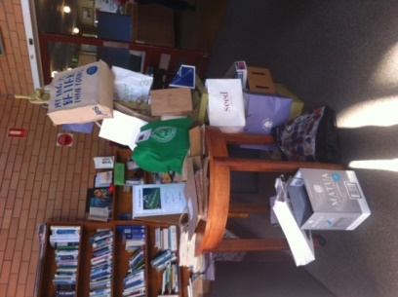 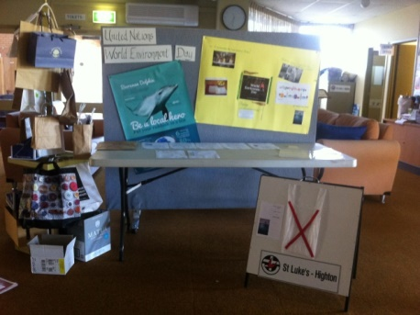

JULY 30 **National Tree Day**

National Tree Day last Sunday (30 July) was a very successful activity.

11 people in total planted, weeded and mulched. Apart from the Environment Group there were 3 young people, 2 people from outside Uniting church, the chairperson of Grovedale Uniting Church and 1 dog.

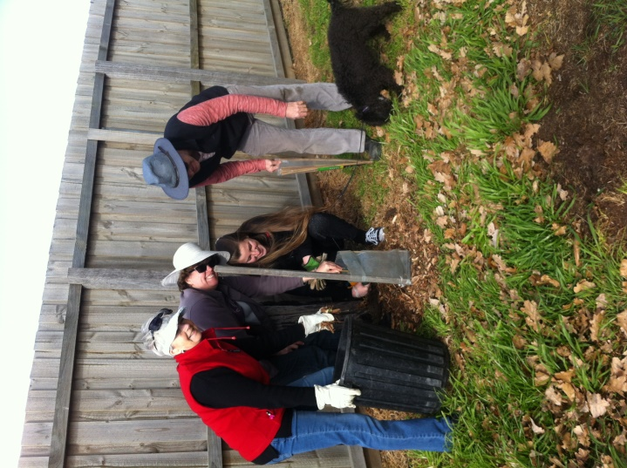 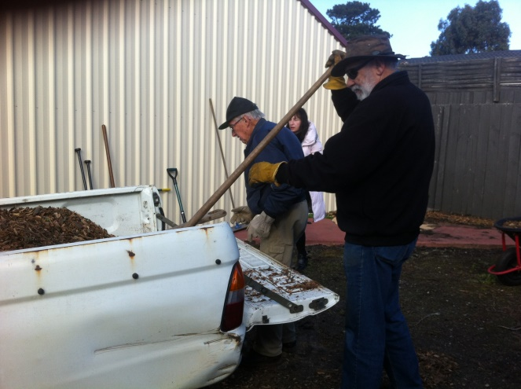

Jean, Michelle, Deb, Ian and Ron

Lloyd and Toto

We planted over 20 indigenous trees, shrubs and grasses along the southern side of the Geelong Uniting Barwon and Grovedale Uniting Church site. Last year’s Tree Day we concentrated on the Eastern side of the property, planting over 20 trees. Therefore a total of over 40 plants, specifically indigenous to the Grovedale area have been planted to improve and enhance the surroundings of Uniting Barwon and Grovedale Uniting Church. 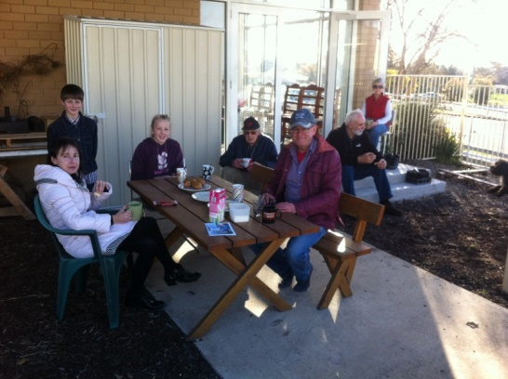 well-earned afternoon tea

AUGUST 5TH

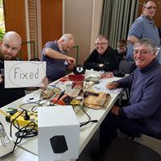



**Join the Geelong Repair Café!**

Repair Café Geelong promotes repair as an alternative to tossing things out. It is planned to operate the first Saturday of every month at St Lukes Uniting Church Highton – starting 5th August 2017 and running the 2nd Sat in the month in 2018,

Anyone can bring their broken items and learn how to fix them with the help of voluntary repairers.

**Repair Café Geelong could use more handy volunteers. Join us!**

We are looking for local residents with different skills who can be present as repair supervisors during the Repair Café meetings. We are especially looking for people who are handy with:

**\* clothing / textile * bicycles**

**\* electrical appliances * furniture / wooden objects**

And who enjoy sharing their knowledge with the community.

In addition, we are also looking for people who wish to fulfil the role of **host / hostess** at the meetings. You provide coffee and tea, welcome visitors and serve as a contact point for both visitors and repairers in the Repair Café.

Want to know more about the Repair Café? Look at the international website Repaircafe.org.

Want to sign up as a volunteer? Sign up at St Lukes facebook page <https://www.facebook.com/stlukeschurchgeelong/> or email Michelle

([michelle@tech4life.com.au](mailto:michelle@tech4life.com.au)) or Claire ([claire.ziegler@iinet.net.au](mailto:claire.ziegler@iinet.net.au))

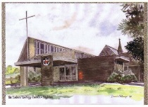 **St Luke’s Uniting Church Highton**

174 Barrabool Road, Highton

Ph. 5244 2997

Email: [stlukes_highton@iinet.net.au](mailto:stlukes_highton@iinet.net.au)

Web: www.hightonstlukes.unitingchurch.org au

**September 3, 2017**

**Jean Murray and Environmental Action Group.**

***This news sheet is available on the website each Saturday evening***



**Forest Sunday**

**Seasons of Creation**

**Eco – worship services**

NOVEMBER 13 - 19 **National Recycling Week**

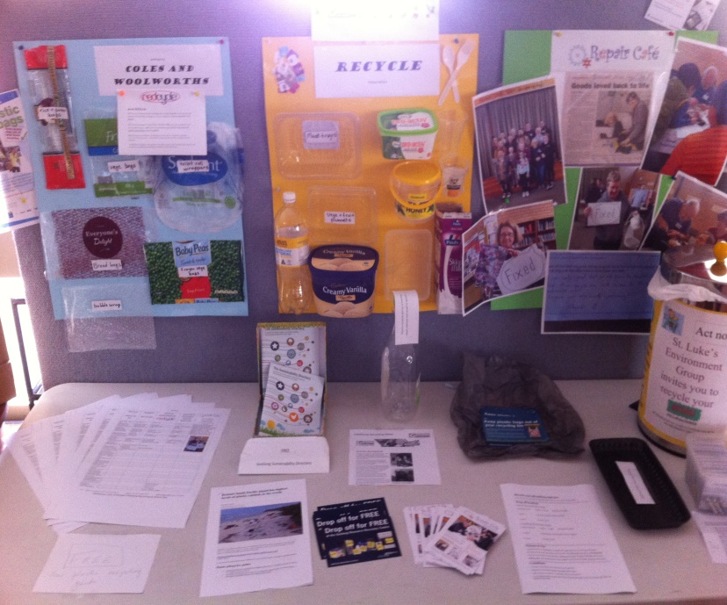

A comprehensive list was compiled of what and where to recycle our daily rubbish.

Reference: City of Greater Geelong website

2016 AND 2017 **5 Leaf Eco Award**

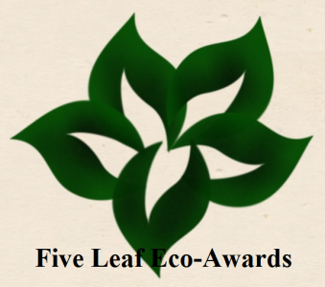

The Five Leaf Eco-Awards are an Australian ecumenical environmental change program specifically designed for churches and religious organisations.

Using a series of non-competitive awards the program assists, inspires and rewards faith communities for taking environmental action and becoming more sustainable

in response to God’s call to care for creation.

Starting with an energy audit at St Lukes and progressing through the criteria of:-

* Conducting “green” events such as World Environment Day, Earth Day, National Recycling Week, National Tree Day throughout 2016 and 2017
* Conducting worship services around the environment as in the “Seasons of Creation” services held in 2016 and 2017
* Showing Community leadership as with the “Vege Patch” for the Food Bank at Grovedale from 2016 ongoing
* Promoting sustainable actions through the Repair Cafe

St Luke’s has succeeded in the basic and the worship categories with the award to be presented at the normal service on February 18th 2018.

________________ __ Claire Ziegler _