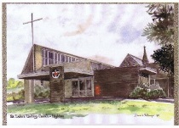

**St Luke’s Uniting Church Highton**

174 Barrabool Road, Highton

Ph. 5244 2997

Email: [stlukes_highton@iinet.net.au](mailto:stlukes_highton@iinet.net.au)

Web: www.hightonstlukes.unitingchurch.org au

**October 1, 2017**

**Rev Helen Robinson**

***This news sheet is available on the website each Saturday evening***





**PRAYER POINTS FOR THIS WEEK COMMENCING SEPTEMBER 10.**

**PRAYER POINTS FOR THIS WEEK COMMENCING Oct 1st**

* Give thanks for all the blessings of the past week, and for God’s ever-present love and compassion. May we express our thanks and praise in faithful service.
* Pray for people in countries where they are persecuted for living out their faith. Pray for minority groups who are treated unjustly and who live in fear. Pray for those who find it necessary to seek refuge in other countries, and that they may be resettled in safety and with dignity.
* Pray for peace in the world and especially for world leaders, that there may be an end to the threat of nuclear disaster, and that leaders may act wisely and with integrity.
* Pray for those living in parts of the world where there are catastrophic natural disasters – earthquake in Mexico, famine in East Africa, floods, fire, hurricanes. Pray for those who have lost loved ones, homes and possessions, and where there is poverty and disease.
* Pray for our own country and its political leaders, for wisdom in decision-making.
* Give thanks for the work of the JNC in seeking a new minister for St. Luke’s, and for the affirmative response of the congregation to the call to the Rev. Paul Stephens.
* Give thanks for Lloyd and all those who have given leadership in ministry during the ministerial vacancy, and pray for Spirit-leading, strength and patience to continue during the extended vacancy.
* Give thanks for the new appointment of Corrine as Office Administrator, and continue to pray for her as she settles in to the various responsibilities of the position.
* Pray for the planning team for Messy Church, especially for more helpers. Praise for the young families who attend, the enthusiasm shown, and for the outreach into the community this has provided.
* Give thanks for Men’s Shed, and it’s outreach into the community, providing practical assistance and fellowship.
* Continue to pray for Uniting Barwon (previously named Uniting Care Geelong), as it ministers to needy families in this area. Pray for the clients, volunteers, staff and board.
* Pray for all those who are sick, frail, facing or recovering from surgery, those who are grieving the loss of a loved one, those who are anxious about the future or who are suffering from depression.
* May each of us strive to make this world a better place, where love triumphs over hate, and the needs of people come before greed and power.



**Consider the links and**

**Chains of Life.**



[This Photo](http://www.anchor.ch/allgemein/freiheit-gebiert-ungewissheit-gebiert-angst/) by Unknown Author is licensed under [CC BY-NC](https://creativecommons.org/licenses/by-nc/4.0/)

We take so much for granted, and never stop to think

That life is but an endless chain and each of us a link; And while the chain’s unbroken and all is going right.

We never spare a moment’s thought for other people’s plight.

We feel that life can’t hurt us, it will always be the same;

And other folk with problems?

Why, they’ve but themselves to blame.

Until the day that tragedy comes, knocking at the door,

And death or illness break the chain that just the day before

was strong enough to hold us all, and keep us safe and warm.

to shelter us from misery, and protect us from the storm,

But time and help from someone else can mend the broken chain,

can forge the links together, and make it whole again.

**SHARING THE JOURNEY:**

During **October** it will be Ian Lawrence. Ian can be contacted on 03 52436817or personally before the service.

***To help keep this segment of Sunday Worship compact, it would be appreciated if announcements could be given to the monthly leader before the commencement of the service.***

**Minister Vote**

At the congregation meeting on 24th September it was agreed to call the Rev Paul Stephens to be the new minster for St Luke’s. The letter of call has been sent. We are awaiting a reply.

**ROSTERS**

**PLEASE ENSURE THAT YOU FOLLOW THE ROSTER WHICH HAS BEEN DISTRIBUTED TO ALL THOSE LISTED FOR DUTY.**

**OCTOBER 8 , 2017**

|  |  |  |  |
| --- | --- | --- | --- |
| **FLOWERS** | G Murrant | **USHERS** | H Swan  J McRobbie |
|  |  | **WELCOMER** | B Murphy |
| **MORNING TEA** | J Pooley &  P Caddy | **CAR DRIVING** | V England |
| **SOUND** | K McAveney | **POWERPOINT** | J Daw |
| **CONNECTIONS** | L Roberston | **READER** | E Nicholls |
| **COMMUNION** | TBA | **COMMUNION**  **SET UP** | TBA |

.

**Upcoming Events**

|  |  |  |
| --- | --- | --- |
| Date & Time | Activity | Contact |
| 7th October  Saturday 7th October 1:00pm-4:00pm | #StopAdani Big Day Of Action  Repair Café St Luke’s Uniting Church | Claire Ziegler  St Luke’s |
| Sunday 8Th October | Refuge Action Sunday Luncheon at St Luke’s | Rae Anderson |
| Friday 13th October 4:30-6:30pm | Messy Church St Luke’s Uniting Church |  |
| Sunday 15th October 2:30-4:30pm | Finding your way in Aged Care  Eastern Reserve, Bennett St Winchelsea | Jenny Mathison 0409672054 |
| Saturday 21st October | Garage Sale |  |
| Sunday 22nd October | 175 years of Worship Wesley Uniting Church 100 Yarra St Geelong | 03 52298866 |
|  |  |  |

***Voluntary Teacher English Conversation Classes***

*St Luke’s is seeking a person to support adult Refugee and Asylum Seekers in the learning of English through Conversation.*

*This position would be ideal for a person who is prepared to share their skills and experience through voluntary work.*

*Start date: 4th. Term 2017, 1 Session x 2 hrs per wk.*

*Desirable skills and experience:*

1. *Experience in teaching or tutoring English in a CALD setting,*
2. *Experience in dealing with newcomer families,*
3. *Demonstrated ability to be cheerful, flexible, outgoing and patient,*
4. *Sensitivity to ‘new arrival’ issues,*
5. *Demonstrated ability to be a “Good Listener”.*

*Expressions of Interest to:*

*Jean Daw Convenor – Mission Outreach Ministry Team*

*Email:* [stlukes_highton@iinet.net,au](mailto:stlukes_highton@iinet.net,au)

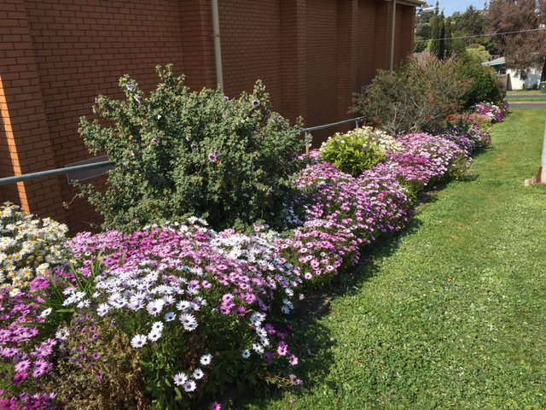

**“SPRING AT ST. LUKE’S**

**Our lovely Spring flower show is due to the many hours of weeding and trimming, carried out**

**over many years, by Joan and Doug Jackson.**

**Thanks Joan and Doug we are appreciative of your work and are enjoying your efforts.”**



**MID-WEEK WORSHIP AND COMMUNION**

**October 1st.**

You are invited to join us in the in Fellowship on

Thursday 12th October for our midweek Communion service

to be led by Rev Helen Robinson.

Mid-week is a traditional form of worship that takes place at 2 pm

on the second Thursday of each month (except in January).

Following each service afternoon tea and fellowship are shared.

For details contact Lyn on 5241 6269.

For transport contact Pam on 5243 9575.



**Christmas Cards**

From Val Grills: Let us think about Christmas, it seems a long way away but our supply of Christmas cards has arrived from the Leprosy Mission who we are supporting this year.  
The cards will be sold in packets of 10 at a cost of $10. They will be on sale  on Sunday 1st October in the foyer, please see Valerie Grills.

**LECTIONARY READINGS**: **October 8, 2017**

**Exodus 20: 1 – 4 .. Psalm 19**

**Phil 3: 4b - 14 .. Matthew 21: 33 - 46**

**______________________________________________________________**

**LAST WEEK’S STATISTICS**

**OFFERING: ACTUAL:** $1,968 **Y.T.D.** $66,925 **BUDGET:** $1,711 **Y.T.D.** $66,726

**THIS WEEK’S DIARY**:

|  |  |  |  |
| --- | --- | --- | --- |
| Mon | 02 | 9:00-1:00 pm  7:00-9:00 pm  7:30-9:30 pm | Office Hours  Geelong Chorale  Mission Outreach Ministry Team |
| Tue | 03 | 9:30-12 noon  5:00-8:00 pm | Men’s Shed  Weight Watchers |
| Wed | 04 | 1:00-3:00pm  6:30-9:00 pm | Pastoral Connections Ministry Team  Welsh Ladies Choir |
| Thurs | 05 | 9:30-12 noon  4:00-5:30 pm  4:30-6:30 pm | Men’s Shed  Choir Practice  Youth Choir (Junior Choir) |
| Fri | 06 | 9:00-1:00 pm  9:30-11:00 am | Office (Closed)  Trekkies |
| Sat | 07 | 1:00pm-4:00pm | Repair Cafe |
| Sun | 08 | 9:30-11:30 am | Worship – Rev Helen Robinson |