

St Luke’s Environment Action Group

November2015 to November 2016

The environment group was left leaderless when Des Younghusband took up his very demanding role as CEO at Uniting Care. Many thanks go to Des for his work with the group. The reins of the environment Group was then taken up by Claire Ziegler at the end of 2015. The following vignettes are some of the highlights of the group from that date for one year.

Climate March 27th November 2015

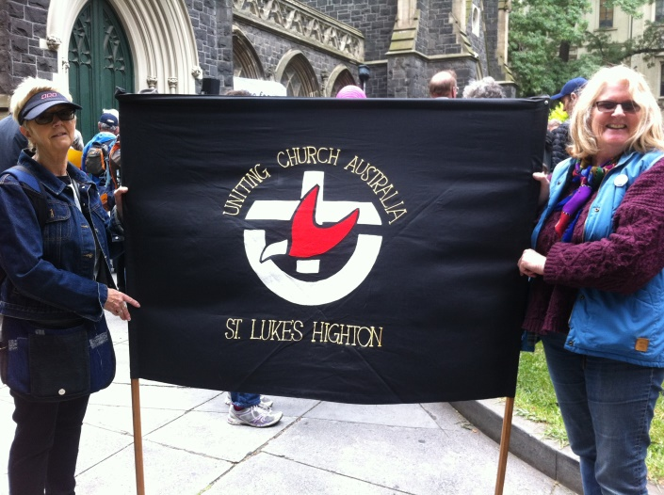Jean and Claire in Melbourne representing St Luke’s amongst an eclectic mix of Christians, Buddhists and other religions. It was very encouraging to be marching with so many like-minded people, all concerned with the changes in the climate and urging the world’s leaders at the Paris Summit to put into action, the changes needed to keep below the 2 degrees rise in the temperature of our planet. Keeping below the 2 degrees rise in temperature is so important to prevent plants and wildlife from being destroyed and low lying countries being flooded thereby people losing their food crops and their homes. My thoughts were :-Are we looking out for each other? Are we looking after God’s creation?

Bible Study 2016 We commenced the study “Spirituality of Soil” in March 2016. It was a very confronting and thought provoking study covering many aspects of the destruction of God’s creation and how we can learn from this/ what is God saying to us.

Clean Up Australia Day 6th March 2016

Ian Lawrence organised this project. We cleaned up from the corner of St Luke’s up Barrabool Rd to the top of the hill and up Scenic Drive, again to the top of the hill. Others outside the church joined in and we managed a very successful cleanup.

The Dell – Clifton Springs April 2016

Michelle, Deborah, Natasha and Claire attended a workshop run by the Port Phillip EcoCentre. The tasks included measuring the sand for erosion, surveying the number of molluscs (very important creatures in the water filtering process) and surveying the litter – a proactive exercise to monitor where the litter is coming from and acting accordingly to prevent same. A fourth survey will be actioned as soon as the equipment is available to monitor temperatures in the water – very important as the creatures in our bay cannot survive the rise in temperature. These surveys are being actioned all around Port Phillip Bay on a regular basis by mostly volunteers of various environmental groups.

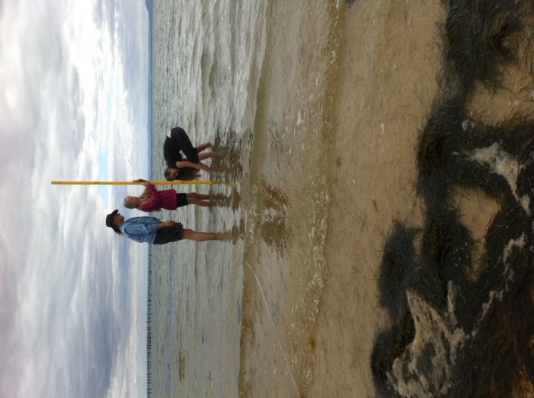Deborah and Natasha measuring sand erosion

Planting at the Manse May 2016

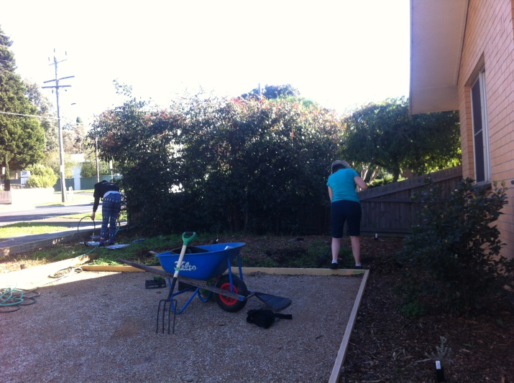

This project started with the resource committee organising the edging of the garden beds and the gravel on the driveway area. The Walker family and Claire then weeded and planted native plants at the front of the manse. Ian Allen organised more mulch and Rex Hunt put in the temporary watering system (just until the seedlings are established).

World Environment Day 5th June 2016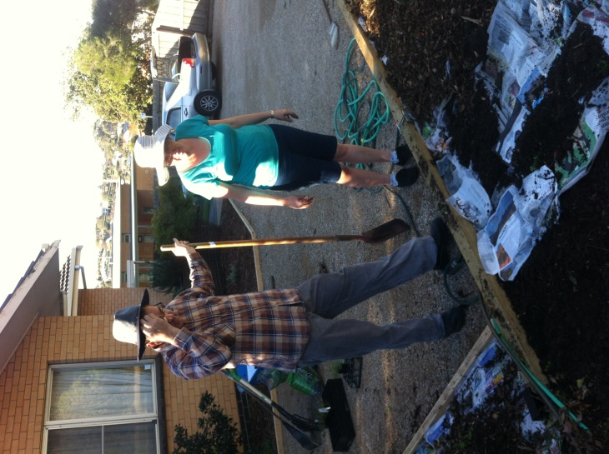

A very successful day was held by the Environment Group and many other willing helpers (from inside and outside our church) on World Environment Day. About 50 – 60 people came to see the beautiful film “Melbourne Down Under” and Lillian’s power point presentation on the Great Barrier Reef. Several ethical and sustainable growers shared their produce with us to taste and to buy as well as native plants for our gardens.

A plethora of information was displayed on endangered species in the world and also specifically in the Geelong area. Mind maps to engage conversation about climate change were placed on the tables along with a quiz on wildlife and more information about endangered species.

You could even find out if your eggs were actually free range on Joel’s computer set up with Cluckar

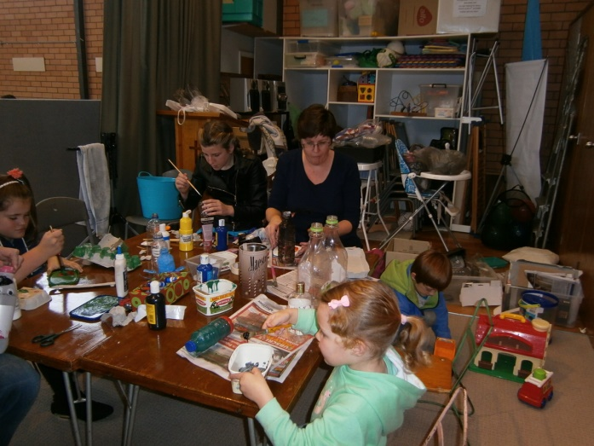Michelle and “In the Wild”, making wild animals from recycled materials

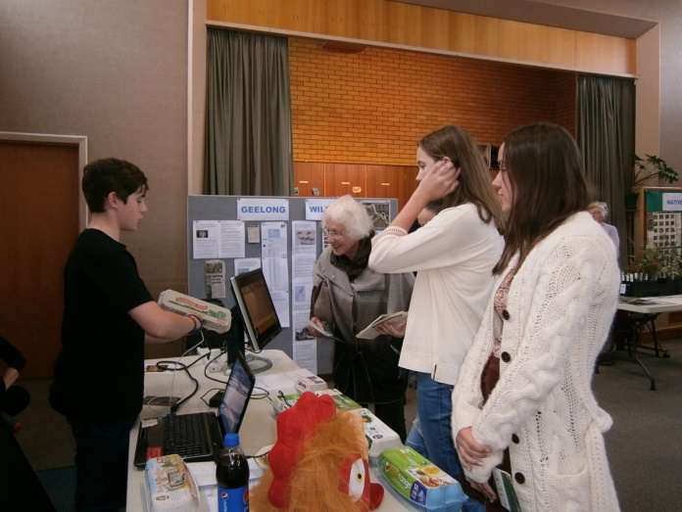Joel and “Cluckar” technology showing whether your eggs are really free range

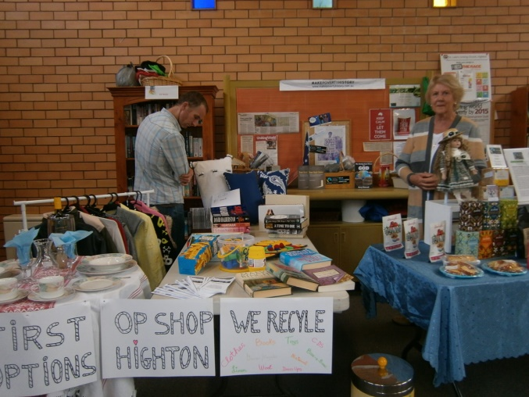Alison and recycling

It was a very successful afternoon with very positive feedback from stallholders and public in general.

National Tree Day, July 31st 2016

St Luke’s Environment Group partnered with Uniting Care and Uniting Church Grovedale to add to the native plantings at the Uniting Care Grovedale site on National Tree Day

There were twelve enthusiastic people at this event including some of the general public, two of whom were scouts working to achieve their badges.

It was a very successful day, even the weather was perfect.

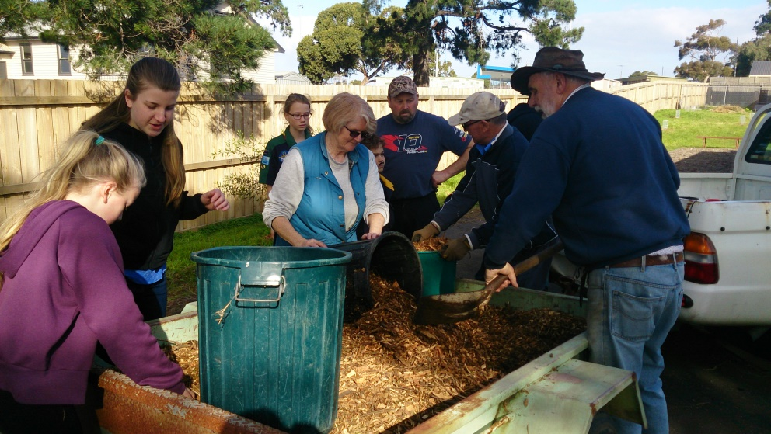

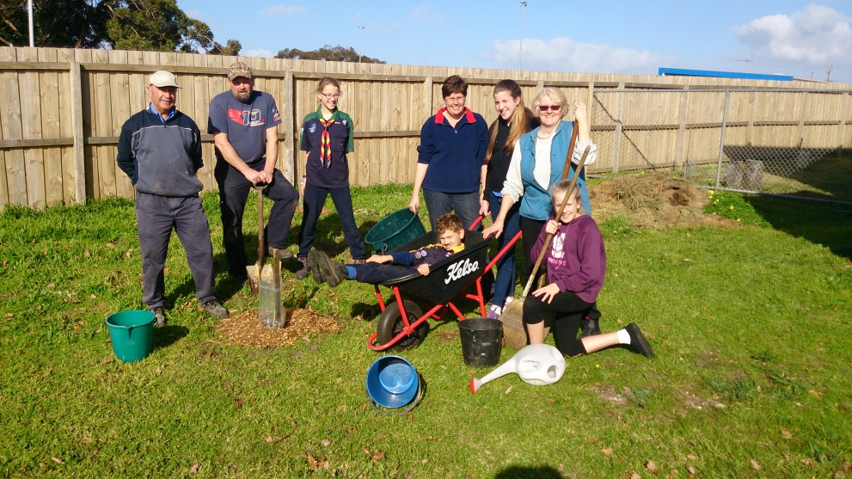

Seasons of Creation Services September 2016

All members of the Environment Group took part in these four services from building stands to technical stuff to leading the services

The following is an example from Fauna Sunday 18th Sept.

From a slideshow in the foyer to children carrying banners depicting endangered fauna

Posters with pictures and information, and candles lit for extinct animals

A great effort was made by many to bring the message of being more mindful and caring of God’s kingdom

Many thanks to all who made this service possible

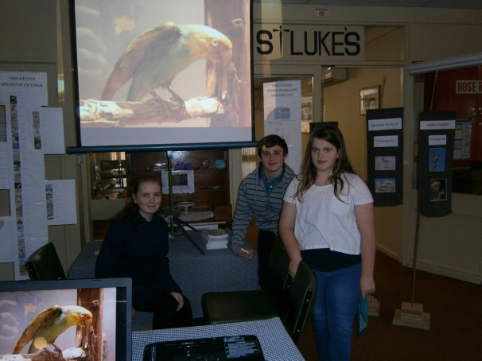 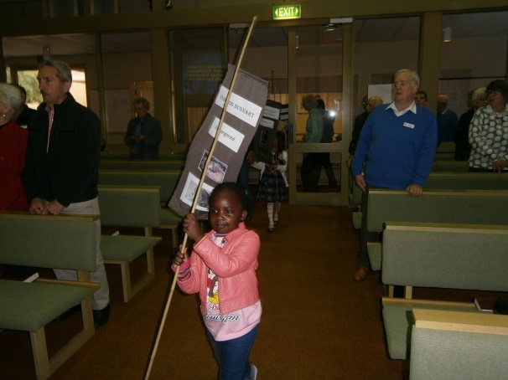

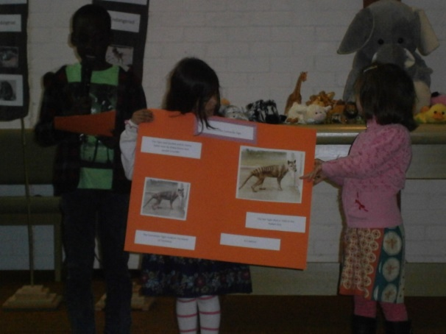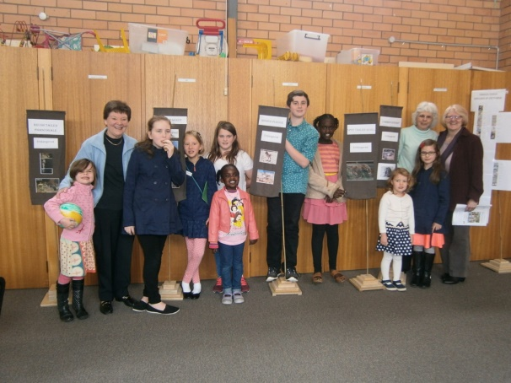

Vege Patch At Grovedale UC for the Food Bank 8th Nov 2016

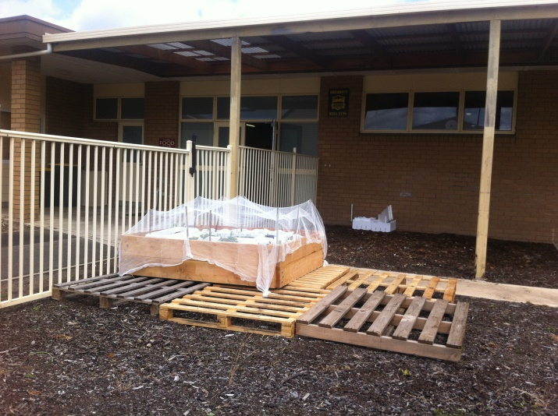

This is a collaborative project between St Luke’s Environment Group, Uniting Care and Uniting Church Grovedale plus Life Assist.

The aim is to grow fresh vegetables for the Food Bank and provide an activity for the Life Assist clients who are eager to help with the garden..

The photo shows the first of several beds to be established.

Reconnect with Friends of Buckley Falls 12th Nov 2016

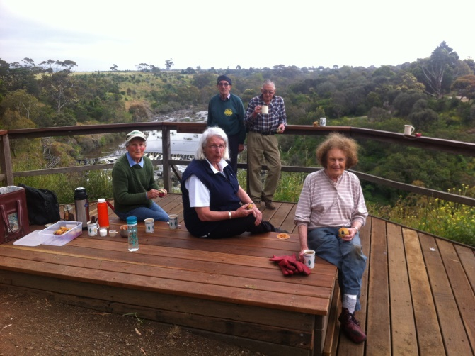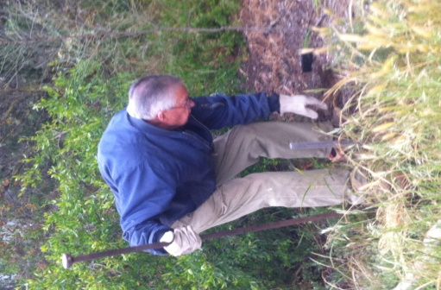

The Environment group reconnected with the Friends of Buckley Falls after the passing of two great men in the group i.e. Tony Woolford and Rod Clark. We had a weeding and planting day on Sat 12th Nov. which included a cuppa and Joan’s delicious blueberry muffins.